**DATE:25.07.25**

**TASK:1**

Implementation of Graph search algorithms

(**Breadth first search and Depth First Search**)

**AIM**

To Implement of Graph search algorithms (Breadth first search and Depth First Search) using Python

**ALGORITHM**

**BFS**

1. Create an empty visited set to keep track of visited spots.
2. Create a queue and add the starting node to it.
3. While the queue is not empty:

* Remove the front node from the queue.
* If the node has not been visited:
  + Mark it as visited and print it.
  + If the node is the treasure, stop and report success.
  + Add all of its neighboring nodes to the queue.

**DFS**

1.Start with the given node and an empty visited set.

2. If the node is not visited:

* Mark it as visited and print it.
* If it is the treasure node, report success and stop.
* For each neighbor of the current node:
  + Recursively apply DFS to that neighbor.
  + If treasure is found in any path, stop.

**PROGRAM**

**Forest Treasure Hunt**

from collections import deque

# Forest map represented as a graph

forest = {

'A': ['B', 'C'],

'B': ['D', 'E'],

'C': ['F'],

'D': [],

'E': ['G'], # Treasure is at G

'F': [],

'G': []

}

# Function to perform BFS

def bfs(graph, start, treasure):

visited = set()

queue = deque([start])

print("BFS Path:")

while queue:

node = queue.popleft()

if node not in visited:

print(f"Visited: {node}")

visited.add(node)

if node == treasure:

print(f"🎉 Treasure found at: {node} using BFS!")

return

for neighbor in graph[node]:

queue.append(neighbor)

print("Treasure not found in the forest using BFS.")

# Function to perform DFS

def dfs(graph, node, treasure, visited=None):

if visited is None:

visited = set()

if node not in visited:

print(f"Visited: {node}")

visited.add(node)

if node == treasure:

print(f"🎉 Treasure found at: {node} using DFS!")

return True

for neighbor in graph[node]:

if dfs(graph, neighbor, treasure, visited):

return True

return False

# Run both searches

start_node = 'A'

treasure_node = 'G'

print("=== Forest Treasure Hunt ===\n")

print("--- Breadth-First Search (BFS) ---")

bfs(forest, start_node, treasure_node)

print("\n--- Depth-First Search (DFS) ---")

found = dfs(forest, start_node, treasure_node)

if not found:

print("Treasure not found in the forest using DFS.")

**OUTPUT**

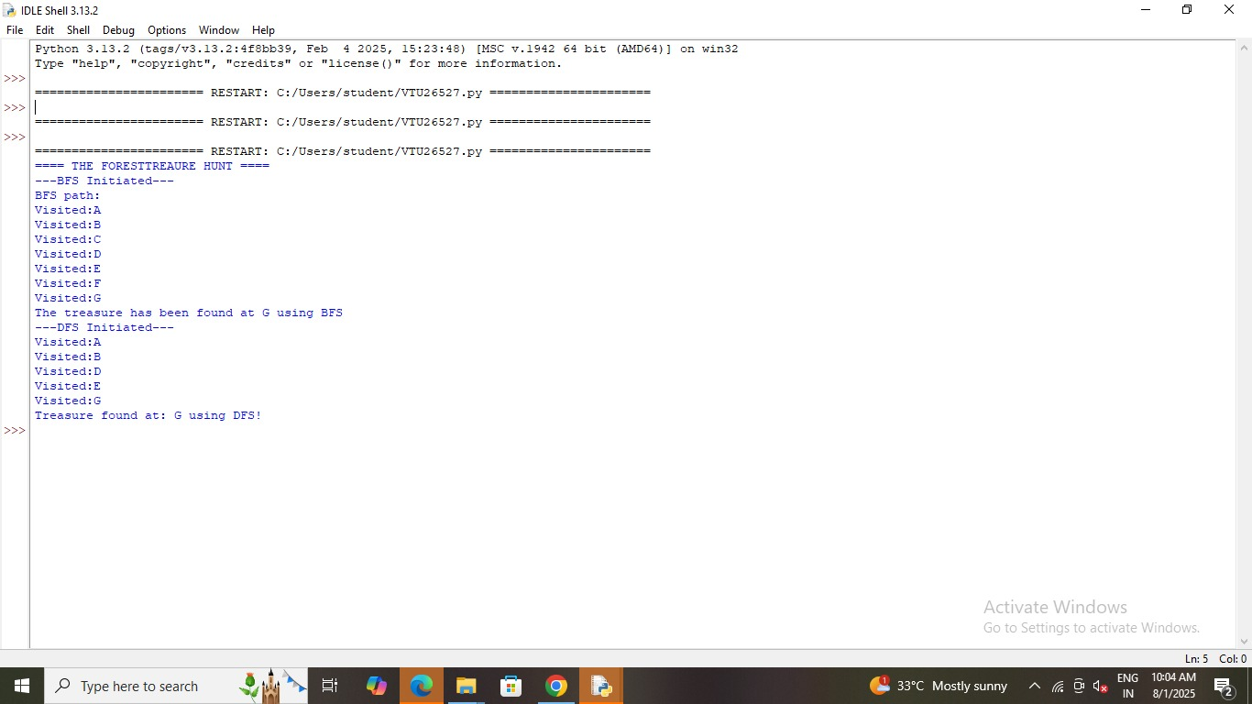

**RESULT**

Thus, the Implementation of Graph search algorithms (Breadth first search and Depth First Search) using Python was successfully executed and output was verified.